Death Certificate

Dr. Gilbert A. Barrett

Date 08th January 1985

This is to certify that the records on my office show that Mr./Ms/Mrs ………......Tobias Bollock Alston …….............................

Died at time………03:10AM……. On the day ……08th ................. of the month……………….January….. …………..and year………1985

Gender……………Male

Age……………….51

Cause of death………………………………………………Hallucinogen overdose (Salvia divinorium)…………………………………………………………………..

Marital Status………………………………….Widower…………………………..

I have here unto affixed my signature alongside a witness on 08th January 1985

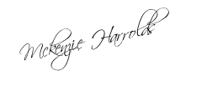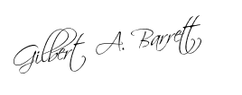

We are issuing this certificate on the specific request of Dr. Angus Montgomery (Stillwater Mental Asylum director) without accepting any liability on behalf of this certificate or part of this on our organization/company.